**Project proposal**

Ukhyeon Shin

([shin.uk@northeastern.edu](mailto:shin.uk@northeastern.edu))

**1. Problem Description**

We are going to solve a problem of game, so called **Omok**. Omok is a game in which two players(agents) alternately place stones on a checkerboard until they win. The winning state of this game is **placing five consecutive stones** (form a chain of five stones horizontally, vertically, or diagonally). Players use black and white stones as they play Go. Sometimes this is played on a 19x19 sized board, a 15x15 sized board is usually used for official matches. We also use a 15x15 sized board for this game.

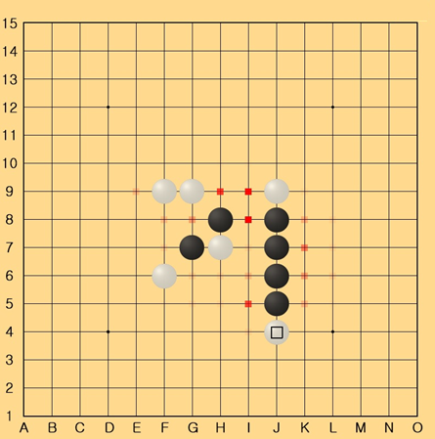

So, the problem we are solving? Describe the problem formally

from a computational perspective.

What are the inputs and outputs (exactly)?

- Inputs of this game is current state. Outputs are next action. So the problem is that search and look for optimal solution for next step that will bring into the final win terminate state.

What data are you using (exactly)?

- We are using tree data structure. And classes that contains information of agent and the game state

Why is it interesting?

- The searching area is big and there is no optimal way to win this game. We find this game would be quite challenging to solve

**2. Approach / Algorithms**

What algorithms do you plan to use? Why are these algorithms appropriate?

This project is a artificial intelligence program using expectimax and Monte Carlo tree search.

How are these algorithms typically used, and how are you using them?

Have other people use similar algorithms to solve your problem before?

**3. Planned Comparisons**

All projects should involve a comparison of some form.

It could be a comparison between two or more algorithms that solve the same problem, a

comparison between different parameterizations of the same algorithm, or a comparison

between the solutions to different versions of the same problem.